Installing Jenkins on AWS VM:

1. sudo apt-get update.
2. sudo apt install openjdk-11-jre.
3. Java --version.
4. sudo mkdir -p /usr/share/keyrings/
5. echo deb [signed-by=/usr/share/keyrings/jenkins-keyring.asc] \ https://pkg.jenkins.io/debian binary/ | sudo tee \ /etc/apt/sources.list.d/jenkins.list > /dev/null
6. sudo apt-get update -y
7. sudo apt install jenkins.

Configure sshd service on jenkins server

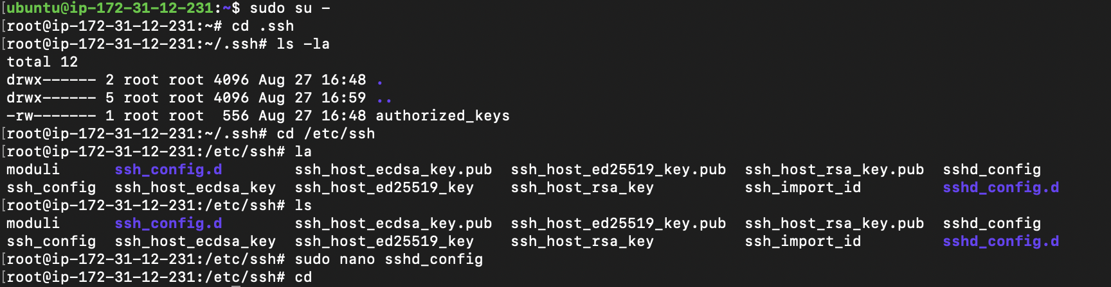

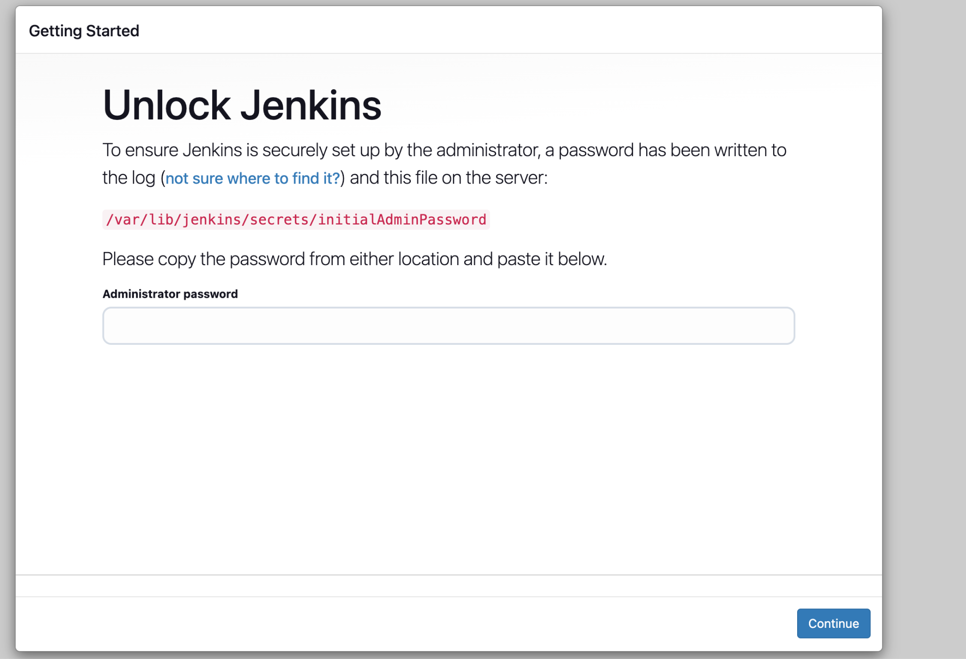

1. Now check the jenkins password
2. sudo cat /var/lib/jenkins/secrets/initialAdminPassword
3. Now change the jenkins password.

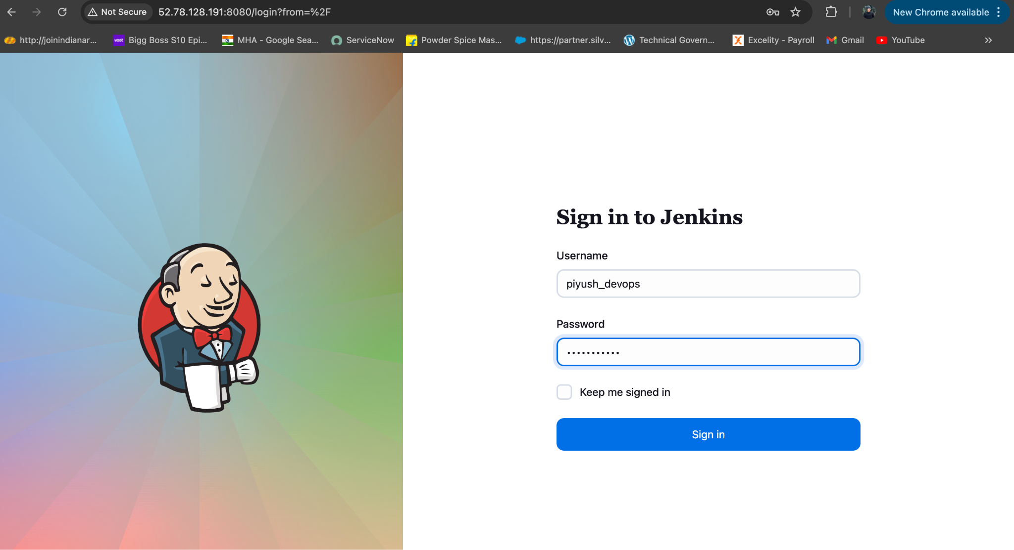

Required Plugins to set up the pipeline:

Manage jenkins → Plugins → publish over ssh, ssh agent, pipeline stage view

Add deployment Server into jenkins:

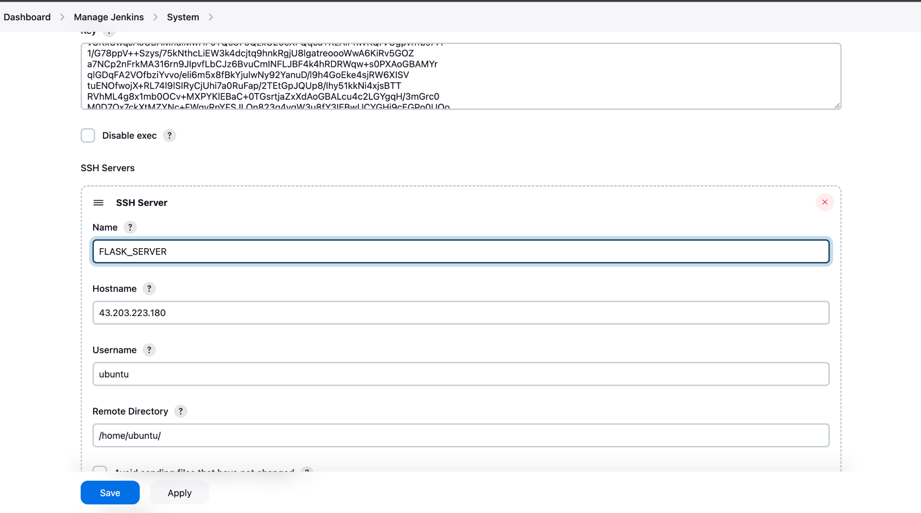

Creating Credentials on jenkins:

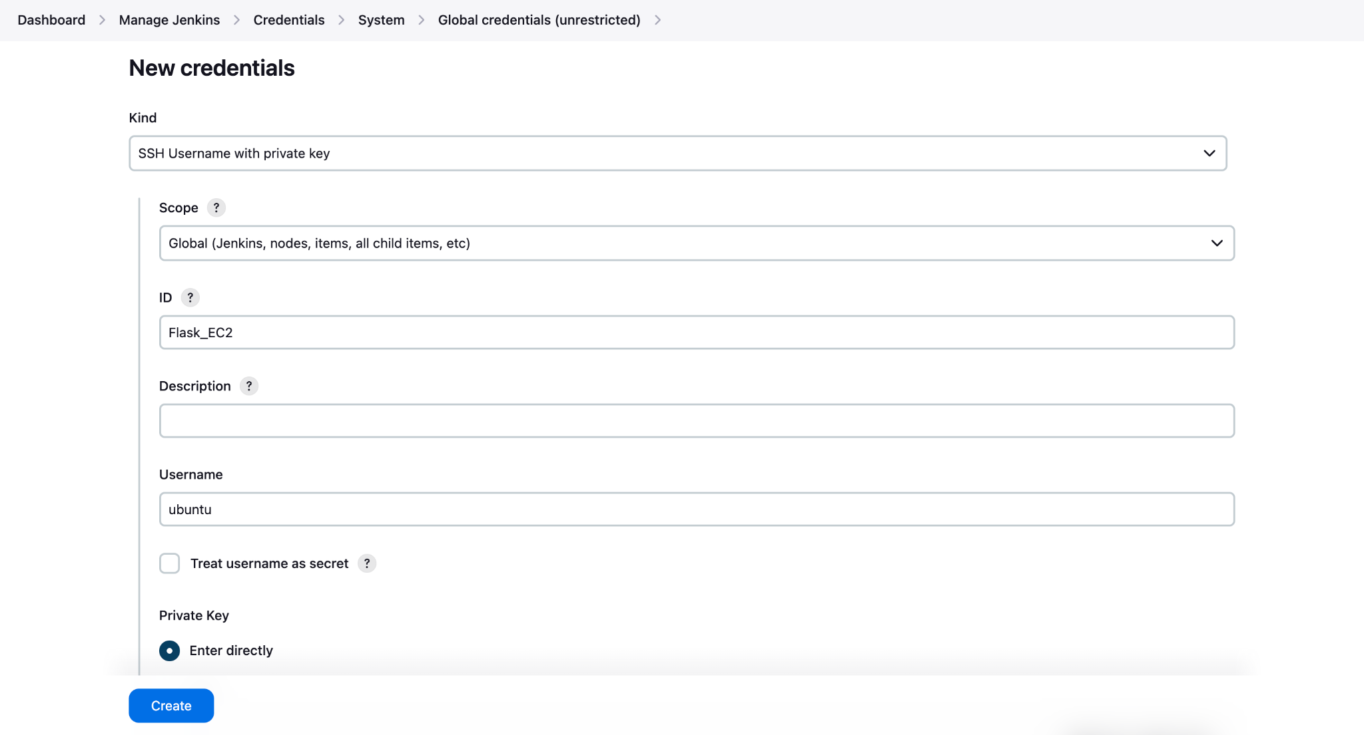

Configure Jenkins with Python and any necessary libraries :

sudo apt update

sudo apt install python3 python3-pip

sudo apt install python3.12-venv → installing environment package

python3 -m venv myenv → This will create separate environment for FLASK app to run on EC2 VM.

source myenv/bin/activate → to switch into environment

pip install flask

Pip3 install pytest

Below we have provided password to the jenkins user:

cat /etc/passwd

sudo passwd jenkins

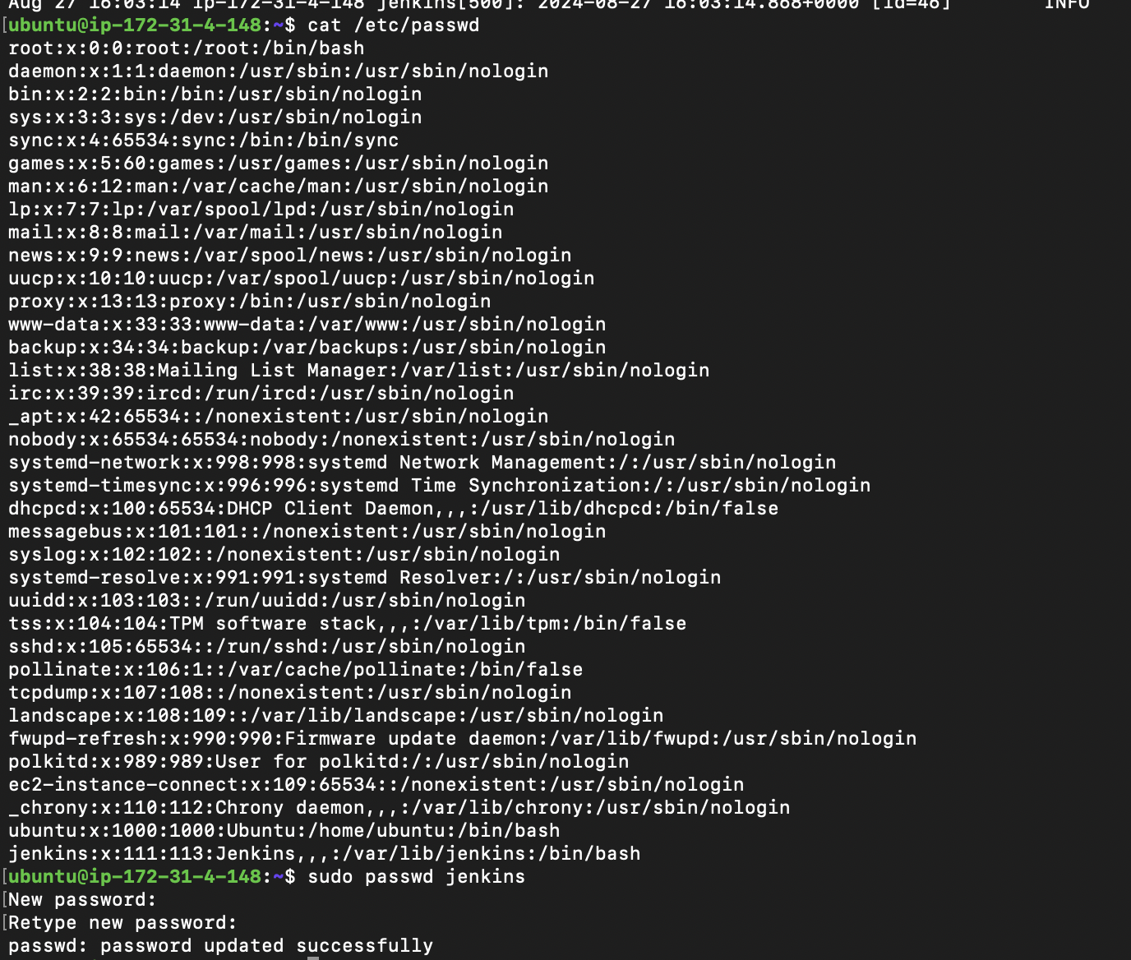

Provide root access to the jenkins user:

First login as a root sudo su -

Second run command cd /etc/

Then nano sudoers and do the below changes

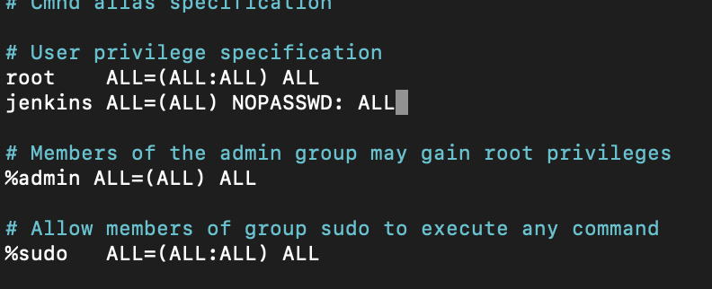

Login as a jenkins user and generate a private/public key:

1. Su jenkins
2. Password
3. Cd /var/lib/jenkins
4. Cd .ssh
5. Ssh-keygen
6. Key will get generated

Below Snapshot:

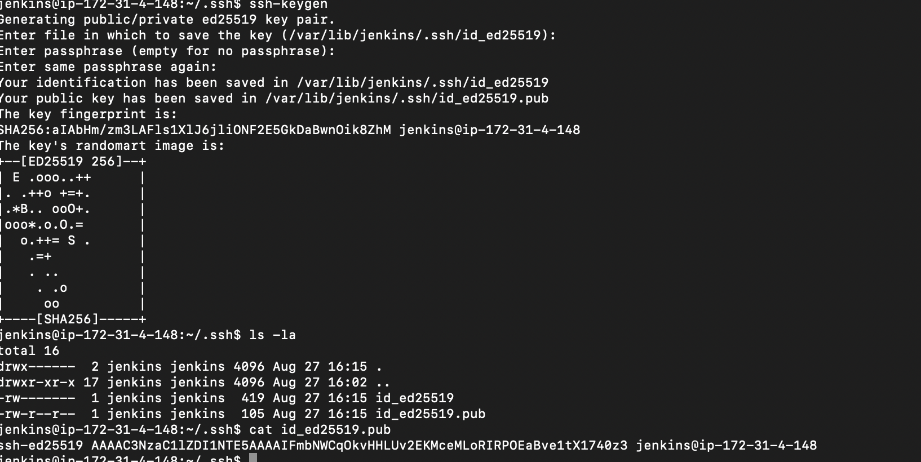

Open another VM on EC2 and do below things:

1. Ls -la
2. Cd .ssh
3. Sudo nano authorized_keys
4. Paste the public key of jenkins server

Below snap for reference

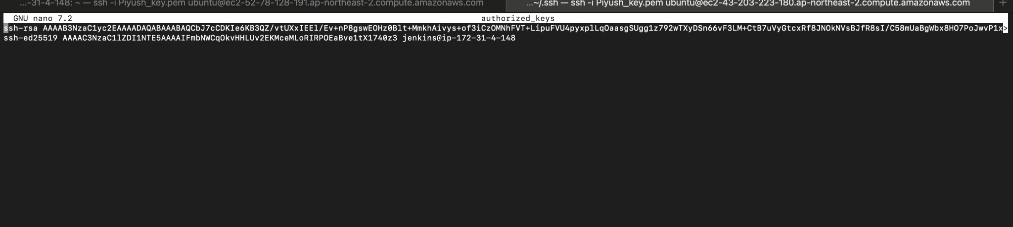

To test the Password less authentication we logged in to ANother VM through jenkins VM

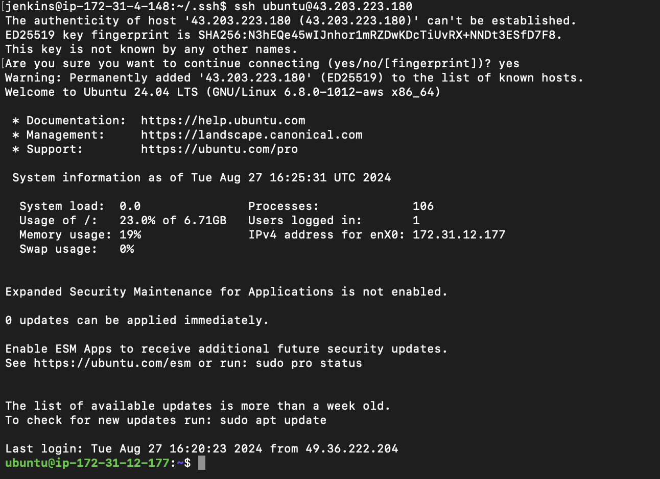

Create credentials on Jenkins Dashboard GUI → Manage Jenkins → credentials

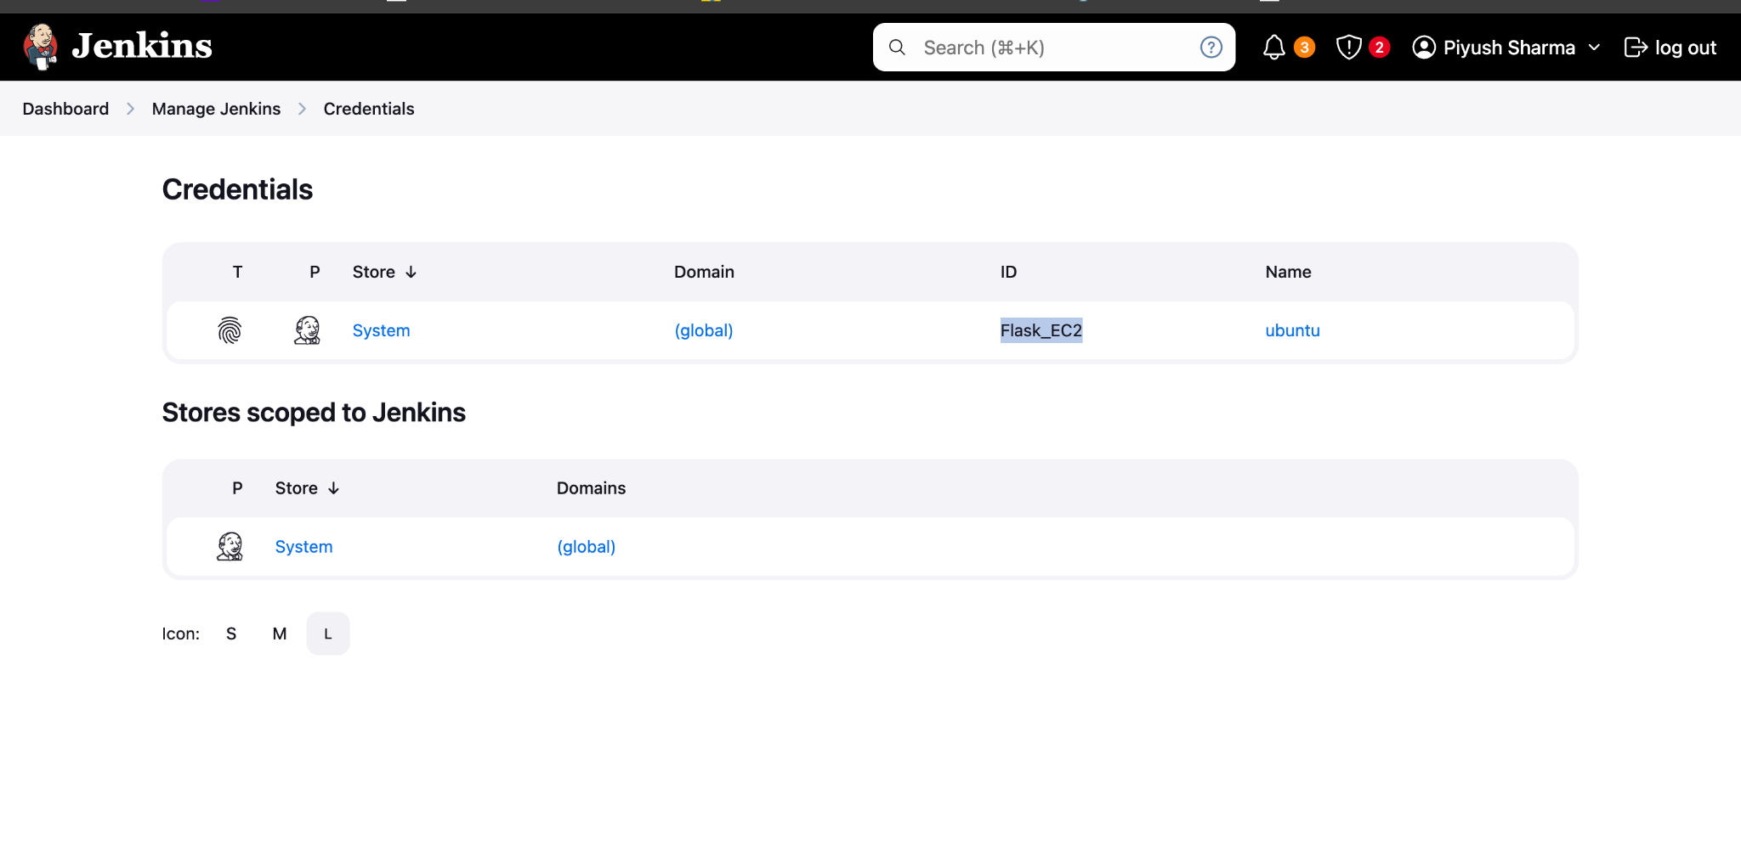

Select job → configure → in Pipeline definition→ select git as SCM

